U.S. Department of Homeland Security

Washington, D.C. 20472

FOR: Dave Webb, Acting Chief
US&R Branch

FROM: Tim Gallagher
Operations Group Chair

SUBJECT: Operations Group Recommendation # IST 08-08

DATE: Dec. 15, 2008

The following recommendation was brought to the Operations Group for approval. The Operations Group voted to approve the recommendation and move it forward for a 21 day review and comments by Task Force Leaders.

ISSUE STATEMENT

- Recent deployment experience has identified the need to have addition technical specialists available to the IST when needed. Prior to rostering personnel into these positions assigned members must qualify for the position and meet a specific position description requirement.

GENERAL BACKGROUND

- The 2005 and 2008 hurricane season demonstrated the value of having technical specialists within the system that could respond to a disaster as part of the US&R Incident Support Teams.

- IST Leaders have asked the IST Work Group develop a position description requirement for the position of IST Veterinary Specialist and begin the recruitment of US&R system members that are qualified for the position and willing to serve when called upon to do so.

- This position would not be part of the IST-A and would be activated only upon request from an IST Leader.

RECOMMENDATION(s)

- The Operations Group recommends the acceptance and approval of the attached IST Veterinary Specialist position description requirement dated Nov. 2008. It is also recommend that a Program Directive be issued stating the acceptance and approval of this position description requirement.

Operations Group Recommendation # IST 08-08
Page Two

ATTACHMENT(S)

- Appendix A - IST Veterinary Specialist position description requirement dated Nov. 2008.

PROGRAM IMPACTS / DOCUMENTATION CHANGES

- IST recruitment announcement will need to be updated with new IST Veterinary Specialist PD.

- After a thorough vetting of applying candidates, qualified members will need to be added to the IST list.

FINANCIAL IMPACT TO TASK FORCES

- Costs associated with sending personnel to the required courses. Varies with each task force based on several factors.

ALLIED WORK GROUP COORDINATION REQUIRED

- Coordination with the Search & Medical Work Groups and the Canine Sub Group has been done.

TIMETABLE FOR IMPLEMENTATION

- No later than Jan. 1, 2009

US&R OPERATIONS GROUP VOTE
VOTE TAKING DATE(s) | Dec. 15, 2008
ISSUE | Operations Group Recommendation # IST 08-08
Work Group Chair Vote |  | Y/N | Work Group Chair Vote | Y/N
C&GS |  | Y | Training | Y
Communications |  | Y | WMD | Y
IST |  | Y | Technical S/C
Legal Issues |  | Y | Canine S/C
Logistics |  |  | TFL Rep | Y
Medical |  |  | East TFL Rep | Y
Public Affairs |  | Y | Central TFL Rep | Y
Rescue (Dave Hammond) |  | Y | West TFL Rep | Y
Search |  | Y | Operations | Y
Grants

DEPARTMENT OF HOMELAND SECURITY
FEDERAL EMERGENCY MANAGEMENT AGENCY

NATIONAL
URBAN SEARCH AND RESCUE
RESPONSE SYSTEM

A Component of the National Response Framework
Emergency Support Function # 9

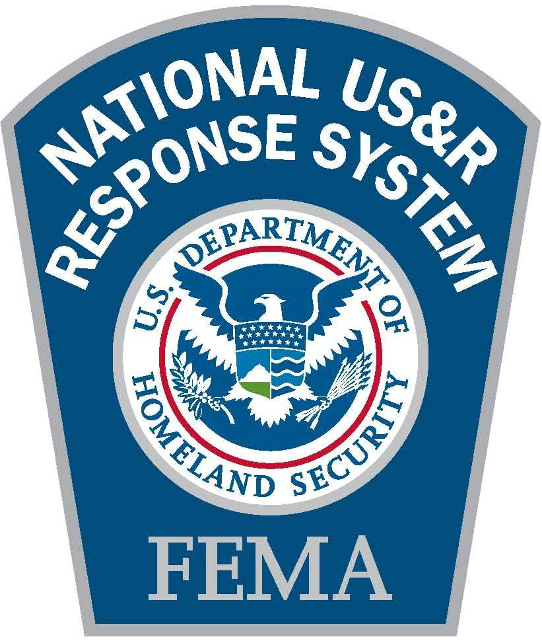

IST VETERINARIAN SPECIALIST
POSITION DESCRIPTION
FEMA National US&R Response System
Incident Support Team Position Descriptions
IST Veterinarian Specialist

Position Specific Description:

The IST Veterinarian Specialist has overall responsibility for the management and supervision of the medical care and evaluations of all Task Force Canines. The IST Veterinarian Specialist reports directly to the IST Medical Advisor/Officer or their deputy.

Description of Duties:

The IST Veterinarian Specialist is responsible for:

- Assisting in the development of all Task Force canine safety procedures in coordination with the other Task Force sections

- Being available to assist in Task Force canine care activities

- Determining the veterinary organizational and logistics needs

- Receiving briefings and situation reports and ensuring that all medical personnel are kept informed of status changes

- Providing situation reports and maintaining records and reports

- Ensuring a continuum of veterinary care and coordinating interaction with all appropriate outside veterinary entities

- Performing additional tasks or duties as assigned

Position Requirements and Criteria:

Individuals who meet the following requirements and criteria will be eligible to become IST Veterinarian Specialists in the DHS/FEMA National US&R Response System.

Required Training:

The IST Veterinarian Specialist shall:

- Meet all Administrative and General Training requirements

- Be a licensed Veterinarian who has experience with canine medical care

- Complete all training as required by the DHS/FEMA National US&R Response System IST Training Matrix

